11.change hardware compatibility of avm which is already created and configured..

Go to vm ware workstation

Create a new virtual machine

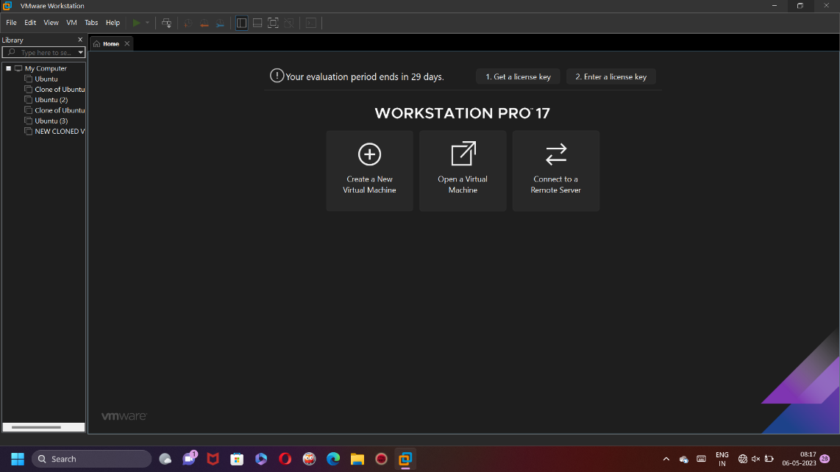

Go to vm and click on manage…

After that change hardware compatibility…

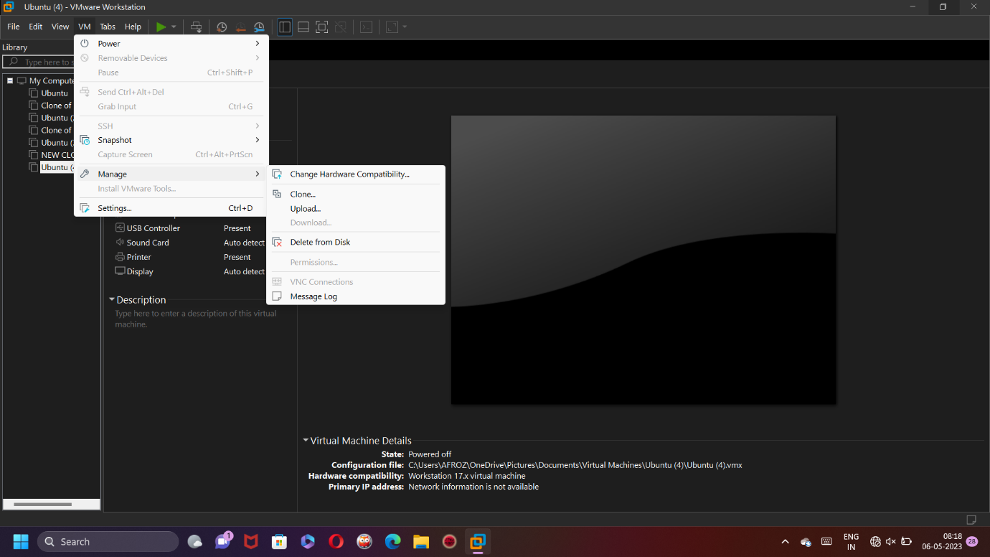

Change workstation as workstation 16.x

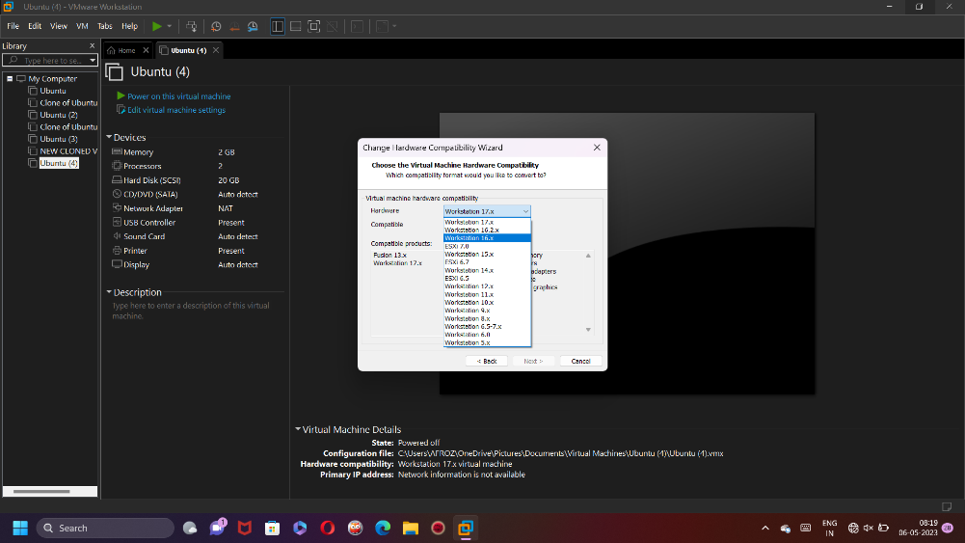

Now create a new clone of this virtual machine..

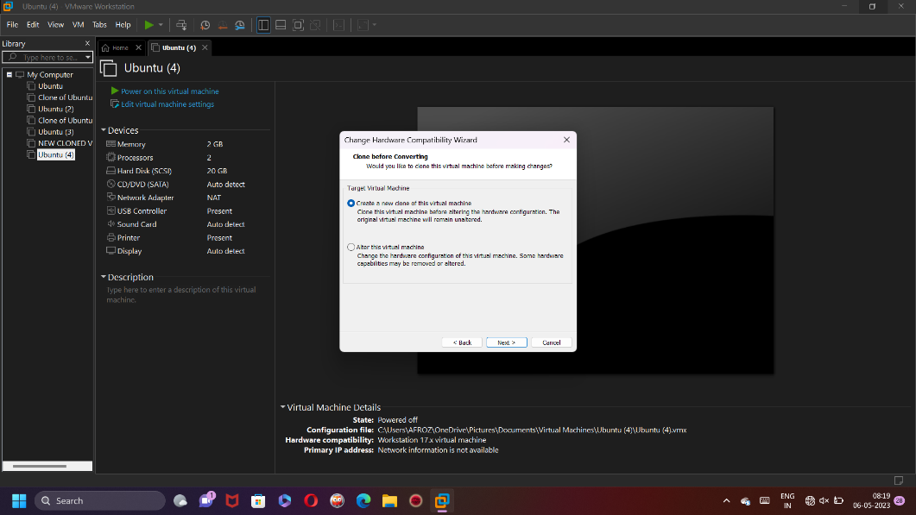

Create a new clone..

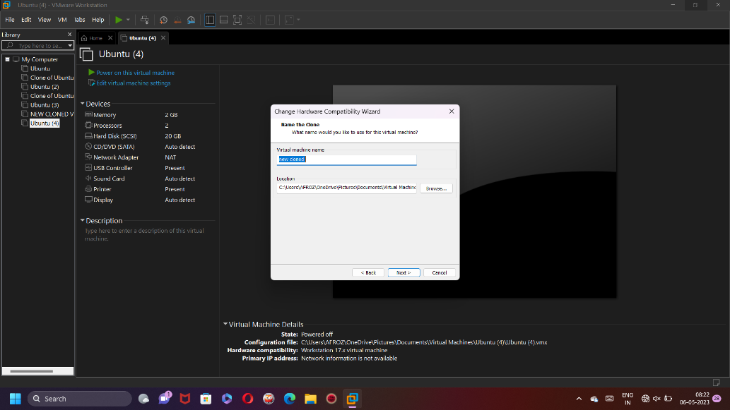

Now click on finish..

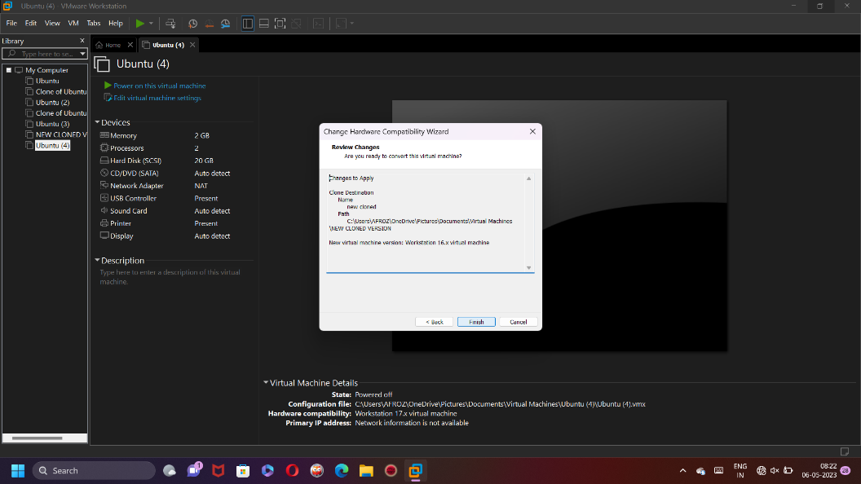

Now our new clone is ready…..

